cnc_rdmacro

声明
/* read custom macro variable */
[DllImport("FWLIB32.dll", EntryPoint = "cnc_rdmacro")]
public static extern short cnc_rdmacro(ushort FlibHndl, short a, short b, [Out, MarshalAs(UnmanagedType.LPStruct)] ODBM c);

描述
读宏变量。

参数
（1）FlibHndl 库句柄；[ in ]
（2）number [ in ]
（3）length [ in ]
（4）macro；[ out ]
/* cnc_rdmacro:read custom macro variable */
[StructLayout(LayoutKind.Sequential, Pack = 4)]
public class ODBM
{
public short datano; /* variable number */
public short dummy; /* dummy */
public int mcr_val; /* macro variable */
public short dec_val; /* decimal point */
}

函数返回值
函数运行正常返回EW_OK。
Return code | Meaning/Error handling
EW_LENGTH  (2) | Data block length error  Size of ODBM structure(length) is wrong.
EW_NUMBER  (3) | Data number error  Custom macro variable number(number) is wrong.
EW_NOOPT  (6) | No option  This function needs the custom macro option.

代码
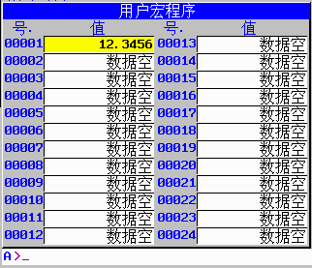
class Program
{
static void Main(string[] args)
{
ushort Flibhndl = 0;

short ret; // 返回值

// 获取库句柄 ( Ethernet )
ret = Focas1.cnc_allclibhndl3("192.168.0.224", 8193, 10, out Flibhndl);
if (ret != Focas1.EW_OK)
{
Console.WriteLine("发生异常，请检查！");
return;
}

#region cnc_rdmacro

short number = 1;
short length = 100;
Focas1.ODBM macro = new Focas1.ODBM();
ret = Focas1.cnc_rdmacro(Flibhndl, number, length, macro);
double data = macro.mcr_val * Math.Pow(10, -macro.dec_val);
Console.WriteLine("用户宏变量" + macro.datano+"的值是"+data);
#endregion
}
}

